‘Plane Training’s Website Terms and Conditions
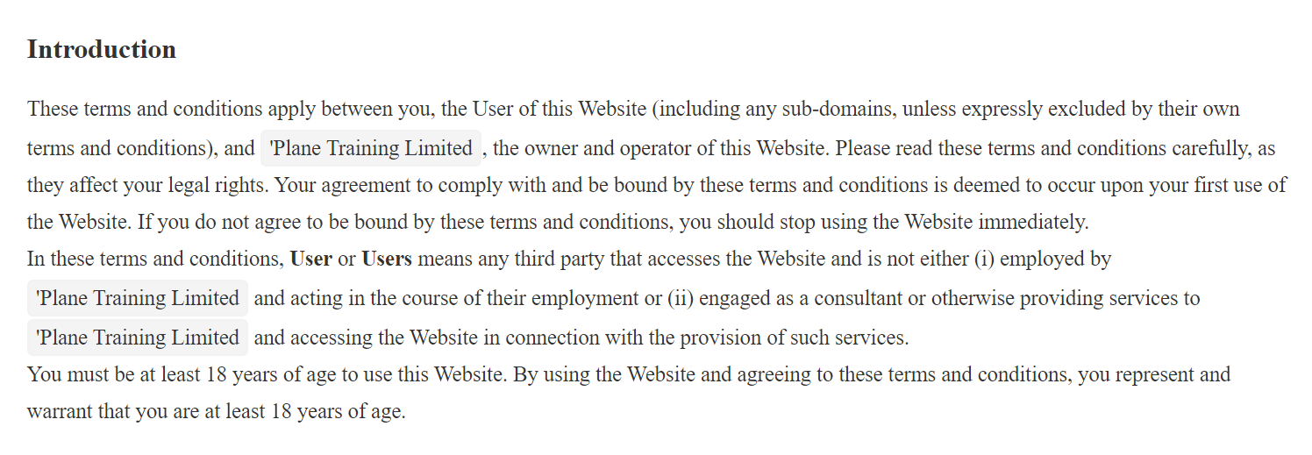
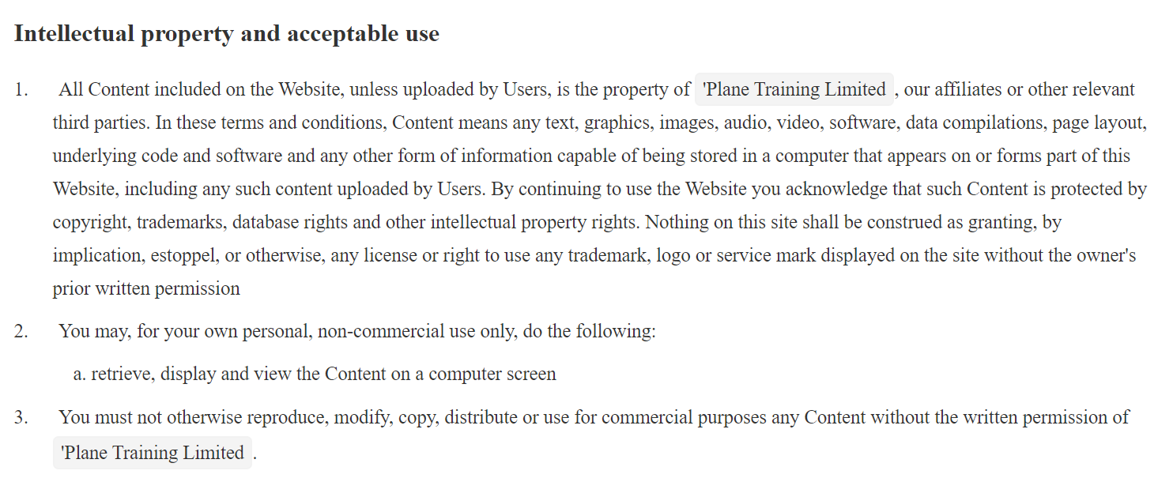
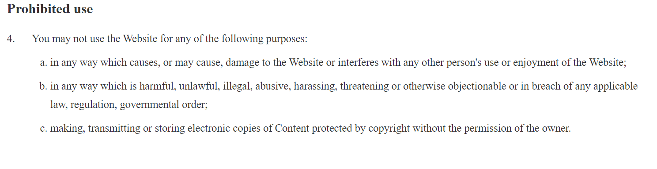
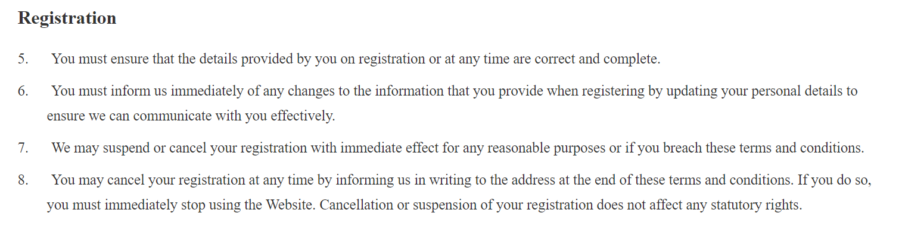
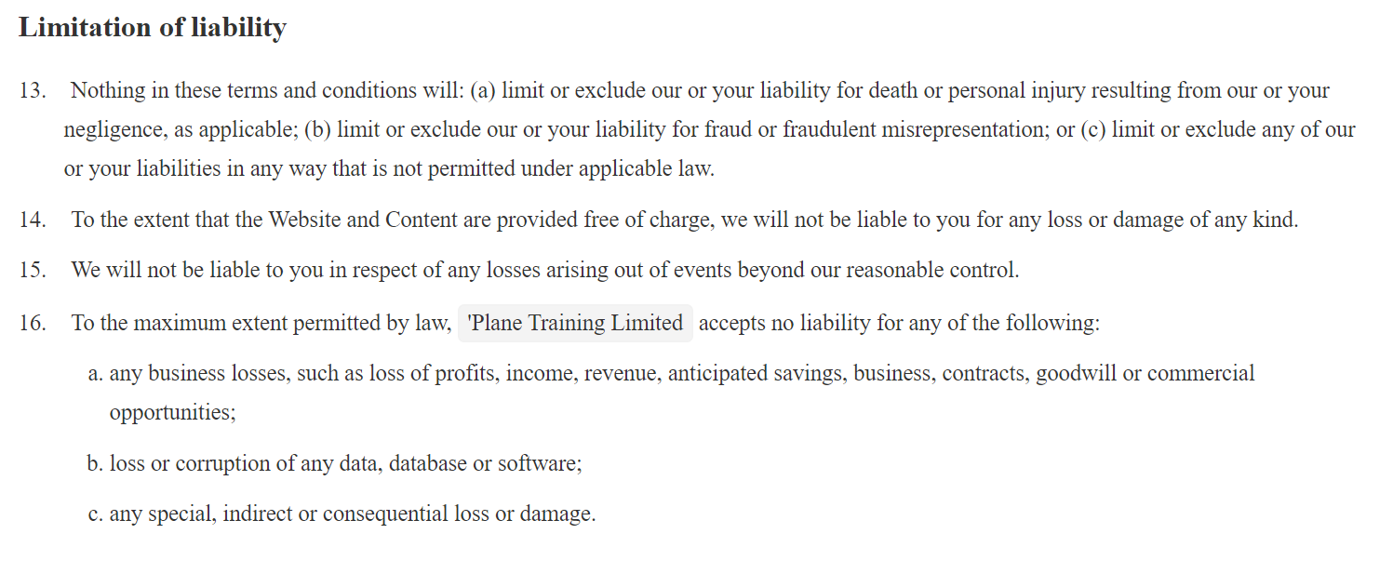
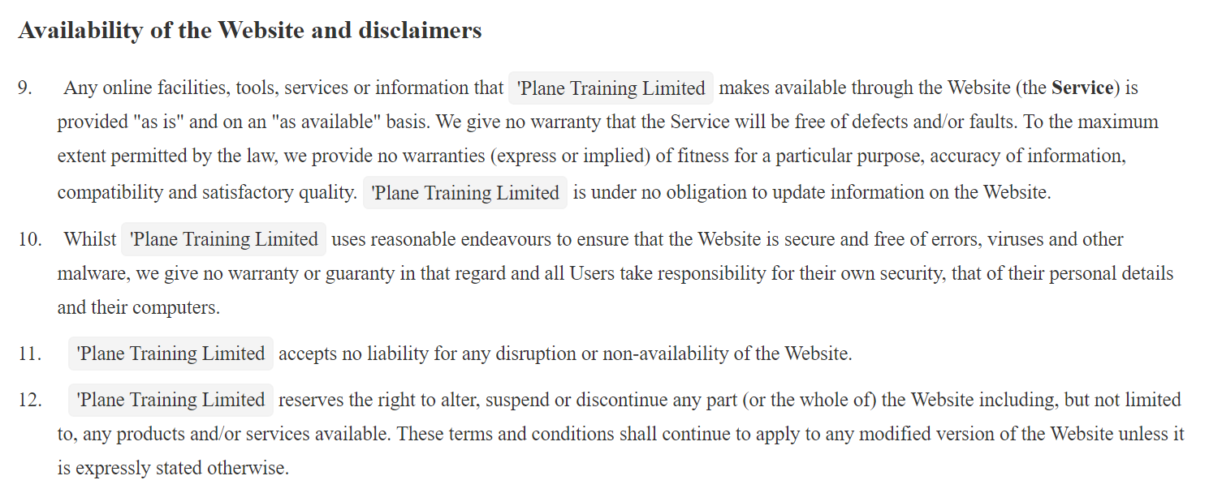
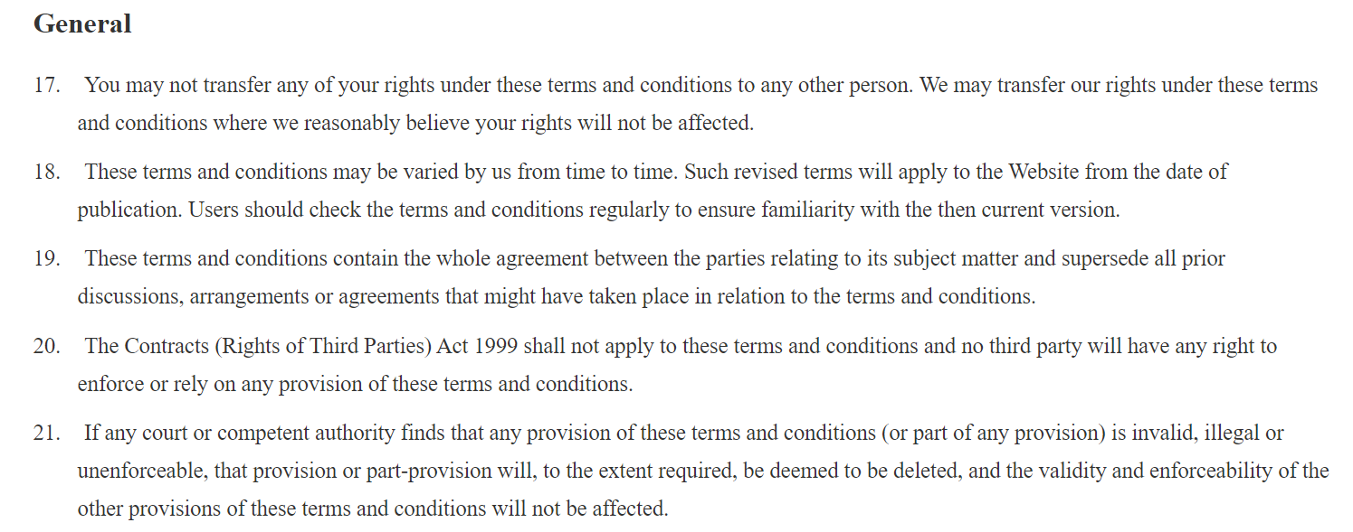

22. Unless otherwise agreed, no delay, act or omission by a party in exercising any right or remedy will be deemed a waiver of that, or any other, right or remedy.
23. This agreement shall be governed by and interpreted according to the law of England and Wales and all disputes arising under the agreement (including non-contractual disputes or claims) shall eb subject to the exclusive jurisdiction of the English and Welsh courts.

‘Plane Training Limited details
24. Plane Training ltd is a company incorporated in England and Wales with registered number 04763606 whose registered address is Newlands Farm Dewhurst Lane Wadhurst East Sussex TN5 6QE and it operates under the Website www.planetraining.co.uk. The registered VAT number is 821628930.
‘Plane Training Ltd can be contacted by email on info@planetraining.co.uk
For our booking terms and conditions refer to “booking Ts and Cs” on the booking and scheduling pages of our website.

